HOW TO BOOK A TICKET IN IRCTC:

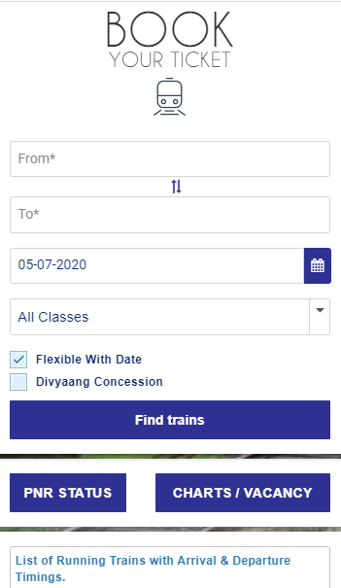

🡪TYPE “IRCTC.CO.IN” IN THE LOCATION BAR

🡪SCROLL YOUR MOUSE ONTO THE COVID-19 ALERT, THEN CLICK ON “OK”

🡪AN DASH BOARD WILL SHOWN UP ON YOUR LEFT SCREENS

* YOU NEED TO ENTER “FROM STATION”
* TO STATION
* DATE OF JOURNEY
* TYPE OF CLASS
* HIT ENTER ON “FIND TRAINS”
* YOU WILL GET THE FALLOWED WINDOW ONTO YOUR SCREEN

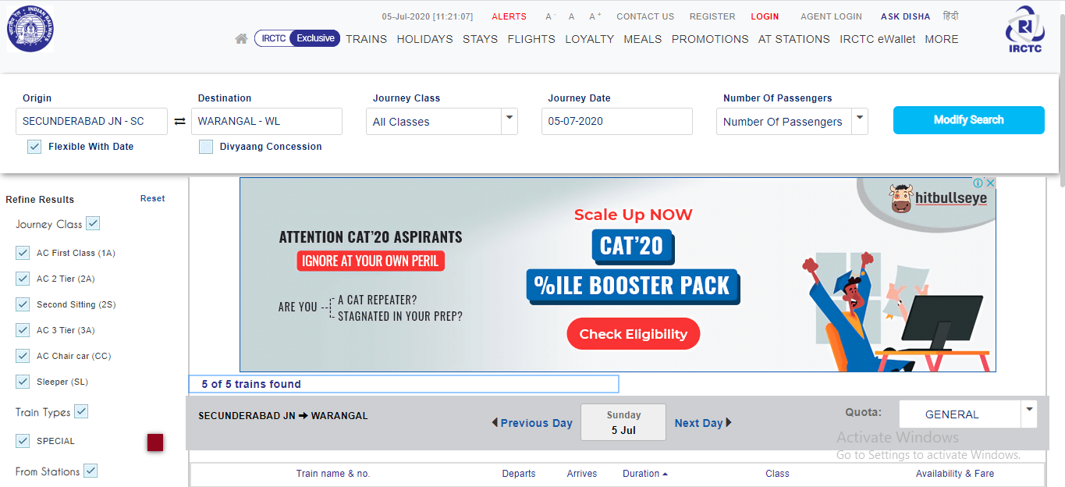

🡪IF YOU WANT ANY FILTERS YOU CAN APPLY/ MODIFY OR JUST SCROLL DOWN TO SEARCH THE TRAINS

🡪SEARCH FOR THE APPROPRIATE TRAIN YOU WANTED

🡪THEN CLICK ON ON THE TYPE OF CLASS YOU WANT TO BOOK LIKE 2S,SL,3 TIER, 2 TIER , 1 TIER OR CHAIR CAR ETC..,

🡪CLICK ON “CHECK AVAILABILITY AND FARE”

🡪IF THERE IS AVAILABILITY CLICK ON “BOOK NOW”

🡪CLICK ON “ I AGREE”

­­­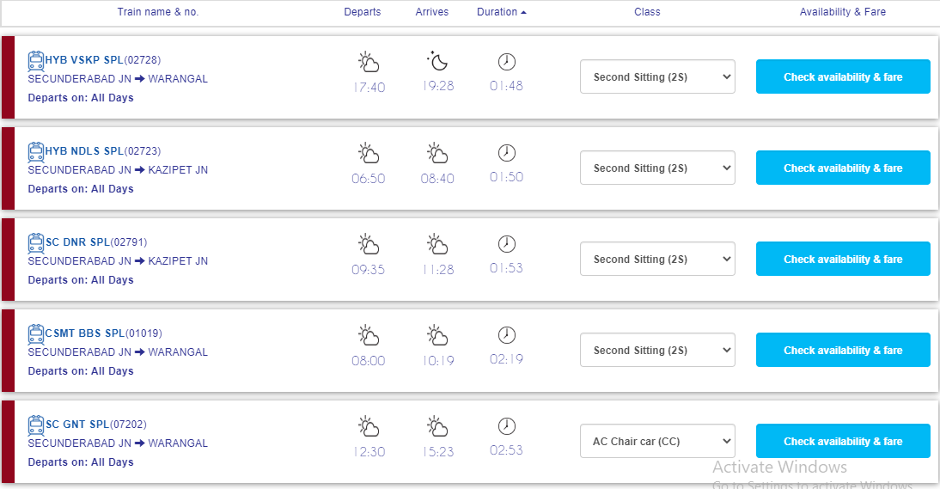

* CLICK ON “OK”

THEN A WINDOW WILL OPEN TO LOGIN

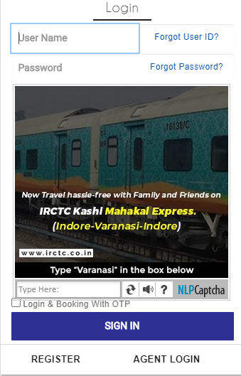

🡪ENTER THE USERNAME

🡪ENTER THE PASSWORD

🡪ENTER THE CAPTCHA

🡪CLICK ON SIGN IN

YOU WILL TAKE TO THE PAGE OF ENTERING YOUR DETAILS

🡪ENTER YOUR NAME

🡪YOUR GENDER

🡪YOUR AGE

🡪ID PROOF

THEN ENTER THE CAPTCHA

🡪GO TO PAYMENTS PAGE

🡪CHOOSE THE TYPE OF PAYMENT

THEN PROCEED

LETS HAVE SOME INSIGHTS INTO THE TITLE BAR OF IRCTC





